Fletchers installation process

# To access this network, use the following steps

To gain access, first download a Citrix Client/Plug-in from this site:

<http://citrix.com/English/ss/downloads/results.asp?productID=186&c1=sot2755>

Then browse to <https://access.fletchers.net.au>

Use the following:

Username - Adept  
Password - DShjwns7

# Network topology assumptions

Please use FLCANAD1 as the web server (with .net4)

A new website with host headers has been setup in readiness – commission.fletchers.com.au

Path is on d:\intetpub\commission.fletchers.com.au

For SQL Please use the default instance on FLCANSQL1 (not the console instance)

# IIS Installation

1. Add the files into the provided IIS directory. Setup the directory to use .NET 4 controls, creating its own app pool if required.
2. Enable the .Net 4 object if disabled
3. Install the Firebird connector to the DB (in the install directory) and configure a **System** ODBC connection using the following settings. (Password is: masterkey)

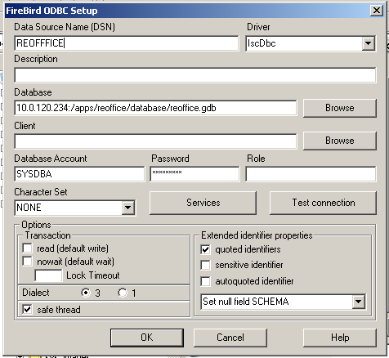

# SQL installation

1. Restore the DB and note the path: **E:\SQL\Commissions**
2. This path will need to be backed up.
3. Create the user that IIS is running in and set it as the db_owner.